SonarQube Email configuration

**Simple Mail Transfer Protocol** (**SMTP**) is an [Internet standard](https://en.wikipedia.org/wiki/Internet_standard) for [electronic mail](https://en.wikipedia.org/wiki/Email) (email) transmission SMTP communication between mail servers uses TCP port 25. [Mail clients](https://en.wikipedia.org/wiki/Email_client) on the other hand, often submit the outgoing emails to a mail server on port 587. Despite being deprecated, mail providers sometimes still permit the use of nonstandard port 465 for this purpose.

Notification Mechanism

During each analysis, [notifications](https://docs.sonarqube.org/display/SONAR/User+Account) are computed for each subscribed user. Then, asynchronously, these notifications are sent via email.

To set the delay between processing of the notification queue, set the sonar.notifications.delayproperty (in seconds) in *SONAR_HOME/conf/sonar.properties*. The server must be restarted for the new value to be taken into account.

# Who gets notifications

Only users who subscribe themselves will get notifications. There is no admin functionality to proactively subscribe another user. If you believe a user should be receiving notifications, then it's time to practice the gentle art of persuasion.

# Email Configuration

To configure the email server, go to **Administration > General Settings > Email**.

Check also the **Server base URL**property at **Administration > General Settings > General** to make sure that links in those notification emails will redirect to the right SonarQube server URL.

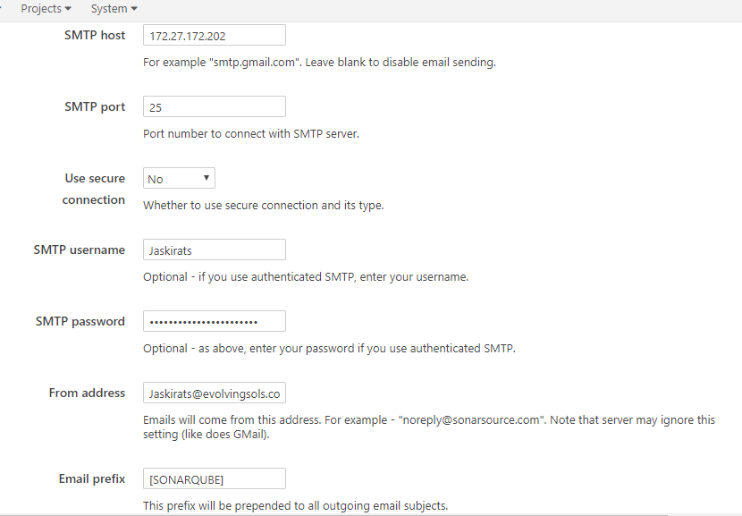

***Notifications can be project level or global level***

For global level user gets notifications for all the analysis of different projects where the user has the permission with respect to each project

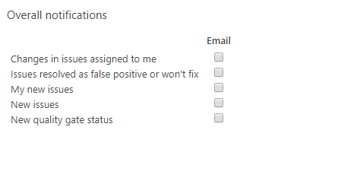

However there is a project level configuration where user can configure notifications project level wise so to avoid unwanted notifications from other projects.

